Project planning document/functional spec

Project scope

This project will give a general awareness over space program activity around the world and give easy to access information about each, it will have a minimum of four pages to ensure this. It will have a contact form with JS validation as well as its recommended to have some sort of calendar or timeline that displays the space program activity easily, with links to live feeds etc. The site needs to be well-designed and easy to use and conform to WCAG standards.

For project week one, I will need to deliver a functional spec/project planning document, Gantt chart. Week two will include a document with my target audience, personae/storyboards, annotated wireframes/sketches and a functional prototype.

Use cases

The reason for people to use this site is to learn more about Nasa and SpaceX’s space program and discover future launch dates and information about them.

Innhold

1 System must 2

1.1 Theme 2

1.1.1 Epic 2

1.2 Theme 2

1.2.1 Epic 2

1.3 Theme 3

1.3.1 Epic 3

# System must

* The site must raise awareness about space program activity around the world.
* The site should appeal to a specific target audience.
* Have links to more information, live feeds of launches etc.
* Minimum of four pages.
* A contact form.
* The site needs to be able to change dynamically if there is new information.

## Theme

The site must raise awareness about space program activity around the world.

### Epic

As a user I want to be made aware of future space programs around the world.

#### Feature

Have a section that specifically shows future space programs around the world.

##### User stories

As a user I want an easy to understand section with information about future space programs around the world, so that I get educated in this.

##### User stories

As a customer I want the option to access more information about different space programs so that I get the information I want or am interested in.

##### User stories

As a customer I want videos and pictures showing space and the opportunities that lies there, so that I easily learn this knowledge.

## Theme

The site should appeal to a specific target audience.

### Epic

As a project leader I want the site to appeal specifically to the youth

#### Feature

Making the design appealing to the youth

##### User stories

As a young customer I want the site to look visually appealing so that my attention is captured

##### User stories

As a young customer I want the site to not have so much text, so I don’t get bored.

## Theme

Have links to more information, live feeds of launches etc.

### Epic

As a user I want more information regarding live feeds of launches etc.

#### Feature

Include live feeds of launches.

##### User stories

As a CEO, I want videos of launches so that we can showcase our rockets to our audience

##### User stories

As a user I want live feeds of launches because they are interesting.

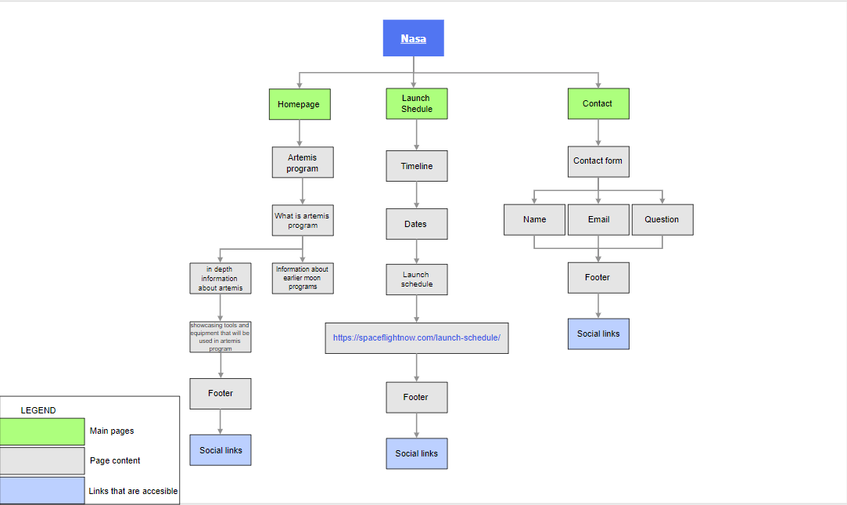

References:

Project scope information: <https://www.projectengineer.net/how-to-write-a-project-scope-statement/>

Site map examples: <https://www.google.com/search?q=site+map&safe=strict&sxsrf=ALeKk02TjxD7ERAOVgGlZ8lWC6Q7hWxndQ:1588693677302&tbm=isch&source=iu&ictx=1&fir=WY33wOMTbckhlM%253A%252CvkLT0zWjdxAuIM%252C_&vet=1&usg=AI4_-kQgbPbOkPViw2w_2zfPQOl4_-vZLw&sa=X&ved=2ahUKEwiw76qSiZ3pAhXNxIsKHYOmCyoQ_h0wAHoECAsQBA#imgrc=zteGyGHXCUshgM>

Functional specifications : <https://www.nopio.com/blog/functional-specification-document/>